The Caregiver Portal
Step 1
CAREGiver will receive link to login and create password
Login to the caregiver portal at http://app.clearcareonline.com
Example: Username: CAREGiver email address
PW: CAREGiver will create password
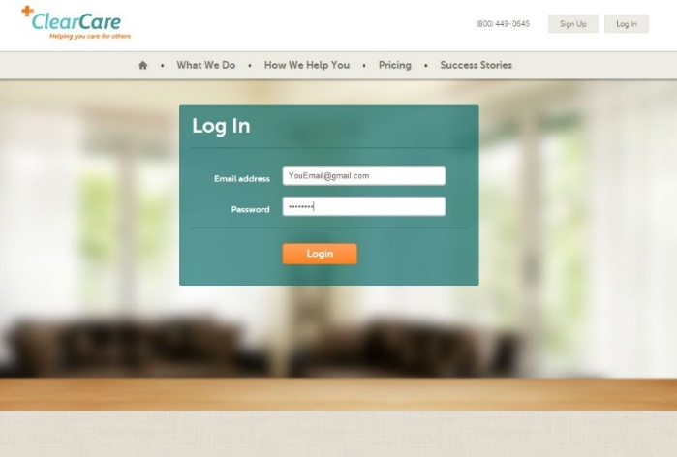
The Caregiver Portal
Through the caregiver portal, you can login to ClearCare to easily access your schedules; upcoming clients' assessments and shift details such as tasks and get directions from your home to the client's. The caregiver portal is view-only you will be unable to edit any of the information that you can view.
What can a caregiver see in the caregiver portal?
When you log in, you will see a calendar showing your shifts. You will be able to change the view to see a monthly, weekly, or daily calendar.
There are three read-only items that a caregiver can view in the caregiver portal:
1) Shift details, including shift times, tasks, status, and whether the shift is part of a series.
2) Client Assessment and Care Plan. Only the assessments and care plans for clients with scheduled shifts with the caregiver will be accessible.
3) Directions to the client home. When this link is clicked Google Maps directions will open in a new tab. The addresses will be pulled from the client and caregiver profiles in ClearCare.
Have more questions about the caregiver portal? One of the best ways to learn more about this feature is to play around with it yourself!

